- Getting started with Technology
Working with Packet Tracer
LEARN TO USE THE SIMULATION TOOL-CISCO PACKET TRACER
- Learning objectives:
- Get acquaintance with CISCO Packet Tracer
  - Two modes – Real & Simulation
  - How to create topology of a simple Local Area Network ?
  - How to configure?
- Play in Real mode
  - How to test ?
  - IP Address : Basic rules & Playing around subnet mask
- Play in Simulation mode
  - Events
  - See how packets move.
  - Get a feel of layers
  - How to analyze a Protocol Data Unit/Packet?
- Difference between the simulation types – ‘Auto capture / Play’ & ‘Capture forward’
- Topology
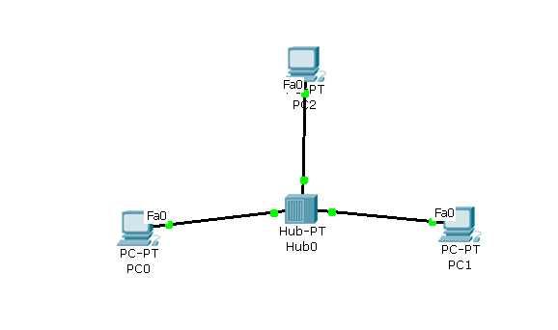

3.Conduction
PartA. Select ‘Real mode’(Default mode is Real mode)
 | Do | What to observe | Write down / Answer the question
1 | Set up the network as shown in the diagram using a HUB
2 | Configure IP addresses  PC0 : 1.1.1.1  PC1 : 1.1.1.2  PC2 : 1.1.1.3 |  | How many interfaces are available in PC0?  Ans :2  What is the name of the interface?  Ans : fastethernet0  How many interfaces are there in HUB ?  Ans :6
3 | Ping from PC0 to PC1  Ping from PC1 to PC0 | Result : Success or Failure ? | Ans : success
4 | Change the setting of PC1’s interface to FULL DUPLEX mode |  | What is the observation  Ans : PC1's FastEthernet0 operates in Full Duplex mode, allowing simultaneous transmission and reception.
5 | Set it back to ‘HALF DUPLEX ‘ mode. |  | Ans : request timed out
6 | Set the IP address of PC1 to 2.2.2.2 & PING between PC0 & PC1 | The status | What is the observation ?  Ans : different ip so can’t  Communicate with each other  What could be the reason ?  Ans :
7 | Set it back to 1.1.1.2 |  | 1.1.1.2
8 | Change the bandwidth of one of the ports of HUB |  | What is the observation ?  Ans :
9 | Keep the cursor on PC0 | IP address | Write down the IP address, as displayed  Ans : 1.1.1.1
10 | Change the subnet mask of PC0 to 255.255.0.0;  Keep the cursor on PC0 | IP address | Write down the IP address, as displayed  Ans : 1.1.1.1/16

Part B. Select ‘Simulation mode’
 | Do |  | What to observe |  | Write down / Answer the question
1 | Ping from PC0 to PC1  &  Click Auto capture & Play |  | Movement of the packet
2 |  |  | Event list |  | How many events have occurred?  Ans : 6
3 |  |  |  |  | How much time is taken to complete pinging task ?  Ans : 0.26
4 |  |  |  |  | What is the name of the protocol ?  Ans :icmp
5 |  | Analyse the first packet  Click on the info field of the first row in the event |  | PDU Information at device PC0
6 |  |  |  |  | How many layers are active out of 7 layers ?  Ans : 4
7 |  | Click outbound PDU details |  |  | How many fields are there in the link layer ( Ethernet) frame ?  Ans : 6
8 |  |  |  |  | How many fields are there in the ICMP packet ?  Ans : 5
9 |  |  |  |  | What is value of TTL in the IP header ?  Ans : 128

Working with Local Area Networks.
1.Learning objectives:
- Get acquaintance with LAN
  - Create a LAN using a Switch(replace HUB with a Switch)
  - Understand the working of a switch
  - Differentiate a hub and a switch
- 2.Topology
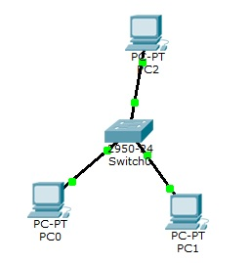
- 3.Conduction
- Part A: Select ‘Real mode’
 | Do | What to observe | Write down / Answer the question
1 | Set up the network as shown in the diagram using a Switch | Observe red dot turning to green. | Ping before it turns to green and after it turns to green. What is the difference?  Ans :
2 | Configure IP addresses  PC0 : 192.168.1.1  PC1 : 192.168.1.2  PC2 : 192.168.1.3 |  | How many interfaces are available in PC0?  Ans :  How many interfaces are there in switch ?  Ans :
3 | Ping from PC0 to PC1  Ping from PC0 to PC2 | Result : Success or Failure ? | Ans :

- Part B: Select ‘Simulation mode’
 | Do | What to observe | Write down / Answer the question
1 | Ping from PC0 to PC1 | Movement of the packet | What is the observation ? Do packets go from all ports?  Ans :
2 |  | Event list | How many events have occurred?  Ans :  Name the protocols.  Ans :

4..Post-Laboratory assignment ( to be written in the observation book, before entering the next lab ]
- Explore 2 differences between SIMULATOR & EMULATOR
- Name at least 3 popular simulators & Emulators

